Reducing Large Language Model Hallucination Using Retrieval-Augmented Generation: A Comparative Study

Abstract—
Large language models (LLMs) can produce fluent answers that include inaccurate or unsupported factual claims. Retrieval-augmented generation (RAG) attempts to improve factual grounding by supplying a model with evidence retrieved at inference time. This study compares a question-only baseline with a lightweight RAG system on 100 paired question-answer records selected from a HaluEval-style dataset. Both conditions use openai/gpt-oss-120b with temperature set to zero. The baseline receives only the question. The RAG pipeline retrieves up to two knowledge snippets using TF-IDF and cosine similarity and supplies those snippets alongside the question. A separate LLM-as-judge procedure labels correctness, hallucination, faithfulness, and retrieval relevance. In the current evaluated outputs, 51 baseline answers and 93 RAG answers are labelled fully correct. Hallucination-positive labels occur in 44 baseline responses and 3 RAG responses, giving observed rates of 44% and 3%, respectively. The 41-percentage-point difference corresponds to a 93.2% relative reduction in labelled hallucination rate. These figures indicate a strong improvement for the tested RAG configuration on this sample, but they are not evidence that RAG universally eliminates hallucination. The experiment is limited by a small deterministic sample, lexical retrieval, model-generated annotations, and different grounding instructions between conditions. The results should therefore be interpreted as a preliminary, implementation-specific comparison.
Index Terms— hallucination, large language models, retrieval-augmented generation, factuality, question answering, HaluEval, TF-IDF.

I. INTRODUCTION
LLMs are increasingly used to answer questions, summarize information, and support knowledge-intensive tasks. Their ability to produce fluent language, however, does not guarantee factual correctness. A generated response may include claims that conflict with the available source material or cannot be verified from the evidence. Such outputs are often described as hallucinations. Detecting hallucination is difficult because a response can be mostly correct while adding one unsupported detail, and a fluent style may make that detail appear credible [1].
One practical mitigation strategy is retrieval-augmented generation. Rather than relying only on the model's parameters, a RAG pipeline searches a knowledge collection for relevant passages and includes the retrieved evidence in the generation prompt. Lewis et al. introduced a widely cited RAG framework that combines parametric generation with retrieved non-parametric memory for knowledge-intensive natural-language processing tasks [2]. This project implements a simpler version suitable for a short course study: TF-IDF vectors rank knowledge snippets by cosine similarity, and the top snippets are supplied to the same language model used in the baseline.
The objective is to compare a baseline LLM that receives only a question with a RAG system that receives the question and retrieved context. The study measures answer correctness, hallucination labels, faithfulness, and retrieval relevance. The experiment is deliberately small and practical; it is intended to demonstrate a reproducible comparative workflow, not to establish a universal ranking of LLMs or retrieval methods.

II. BACKGROUND AND RELATED WORK

A. Hallucination and Its Evaluation
For this study, hallucination is operationalized as a material factual claim that is unsupported by the evidence available for evaluation or is contradicted by that evidence. This definition is narrower than treating every incorrect answer as a hallucination. Correctness concerns whether the response answers the question accurately; faithfulness concerns whether claims are supported by the designated evidence. These dimensions can overlap without being identical. For example, an answer may give the correct date but add an unsupported claim about the reason for the event.
Li et al. presented HaluEval, a benchmark containing generated and human-annotated examples for evaluating hallucinations across general queries, question answering, knowledge-grounded dialogue, and summarization [1]. Their work also reports that external knowledge can improve hallucination recognition. The current study uses a small question-answering sample and a separate judge procedure; it does not reproduce the full benchmark protocol or its original evaluation design.

B. Retrieval-Augmented Generation
RAG combines a generator with an explicit evidence-retrieval component [2]. Its potential benefit is that the model can condition its answer on information supplied at inference time rather than relying exclusively on what it learned during training. However, retrieval does not guarantee factuality. The retriever may return irrelevant or incomplete passages, the model may ignore relevant evidence, or the evidence itself may be insufficient or incorrect. Therefore, a RAG system must be assessed at both retrieval and generation stages.

C. Position of This Study
This work is a small-scale implementation study using TF-IDF retrieval rather than a dense neural retriever. It focuses on a controlled, paired comparison with the same generation model and temperature. Because the RAG prompt explicitly encourages evidence use and abstention, the comparison measures the overall RAG approach—including retrieval and prompt design—not the isolated causal effect of retrieval.

III. RESEARCH QUESTIONS AND CONTRIBUTIONS
The study addresses the following research question:
RQ1: On the selected 100 questions, how does a question-only baseline compare with a TF-IDF-based RAG system in answer correctness, hallucination labels, faithfulness, and retrieval relevance?
The practical contributions are:
- A reproducible baseline-versus-RAG pipeline using a common generation model.
- A lightweight retrieval implementation using TF-IDF and cosine similarity.
- A paired response dataset with automated evaluation labels for preliminary comparison.
- A discussion of evaluation limitations, prompt confounding, and steps required for a stronger follow-up experiment.

IV. METHODOLOGY

A. Experimental Design
A paired design was used: each selected question was submitted to both the baseline and RAG conditions. Both conditions used openai/gpt-oss-120b at temperature 0. The question IDs were retained to support row-level matching. The experiment was executed through Python scripts and the Groq API. Completed responses were saved to CSV files so that an interrupted run could resume without regenerating already completed records.

B. Dataset and Sample
The input file qa_data.json contains fields including knowledge, question, right_answer, and hallucinated_answer. The project configuration selected the first 100 usable records deterministically. The right_answer and knowledge fields were retained for evaluation, while the baseline generation prompt received only the question. This distinction prevents the baseline from directly accessing the supplied knowledge during generation. Because records were selected by position rather than randomly, the sample is a convenience/pilot subset and may be affected by ordering.
The HaluEval authors describe a benchmark containing approximately 35,000 examples across general user queries and task-specific examples [1]. The experiment in this report uses only 100 question-answer records from the project dataset and should not be described as an evaluation of the entire benchmark.

C. Baseline Condition
The baseline receives the question only. Its system instruction asks it to answer accurately and concisely using its existing knowledge, not to claim it consulted external documents, and to acknowledge uncertainty instead of inventing details. The baseline response is stored with the question ID, reference answer, knowledge field for later evaluation, model identifier, temperature, and response text.

D. RAG Condition
The retrieval corpus is assembled from unique, non-empty knowledge snippets in the selected records. A TF-IDF vectorizer with unigram and bigram features represents the snippets. For each question, the question text is transformed using the same vectorizer, cosine similarity scores are calculated against the corpus, and the two highest-ranked snippets are selected (top-k = 2). The retrieved context and question are then sent to the generation model. The RAG instruction directs the model to ground its answer in the provided context and to indicate when the evidence is insufficient.

E. Evaluation Procedure
A separate large language model (LLM)-as-judge script was used to evaluate the generated responses. The evaluated CSV files contain labels for answer correctness, hallucination, faithfulness, and retrieval relevance, where applicable. These evaluation labels were stored separately from the raw generation outputs to preserve the original model responses and support transparent analysis. Four baseline responses were labelled as both “Correct” and “hallucination-positive.” These labels are not necessarily contradictory, because a response may answer the main question correctly while also including an unsupported factual claim. However, these cases require verification against the reference answers and available evidence to assess the consistency of the labels. The evaluation results should therefore be interpreted in light of the limitations of automated judging, and a consistent annotation rubric should be maintained for future validation.
Dimension | Working definition
Correctness | Whether the response answers the question accurately: Correct, Partially correct, Incorrect, or Unanswerable/insufficient evidence.
Hallucination | Whether the response contains a material unsupported or contradicted factual claim: Yes, No, or Unclear.
Faithfulness | Whether material response claims are supported by the evidence used for assessment.
Retrieval relevance | Whether retrieved passages are relevant and sufficient, relevant but incomplete, irrelevant, or provide no useful evidence.

F. Outcome Measures
The fully correct rate is the number of responses labelled Correct divided by the number of evaluated responses. The hallucination-labelled rate is the number labelled Yes divided by the number of evaluated responses. The absolute difference is the baseline rate minus the RAG rate. Relative reduction is calculated as (baseline rate − RAG rate) / baseline rate × 100%. These descriptive calculations depend on the correctness of the labels and do not, by themselves, establish statistical significance or causal attribution.

V. SYSTEM IMPLEMENTATION

A. Software and Configuration
Component | Implementation
Language | Python
Generation API | Groq API using an OpenAI-compatible chat-completions endpoint
Model | openai/gpt-oss-120b
Temperature | 0
Data format | JSON input; CSV outputs
Retrieval | scikit-learn TF-IDF vectorizer and cosine similarity
Data handling | pandas; resumable row-level CSV saving
Evaluation | Separate LLM-as-judge script

B. Processing Flow
Stage | Baseline | RAG
Input | Question | Question
Evidence | No supplied knowledge at generation time | Top two retrieved knowledge snippets
Generation | GPT-OSS-120B; temperature 0 | Same model and temperature
Output | Baseline answer CSV | RAG answer CSV
Evaluation | Correctness, hallucination, faithfulness | Same plus retrieval relevance

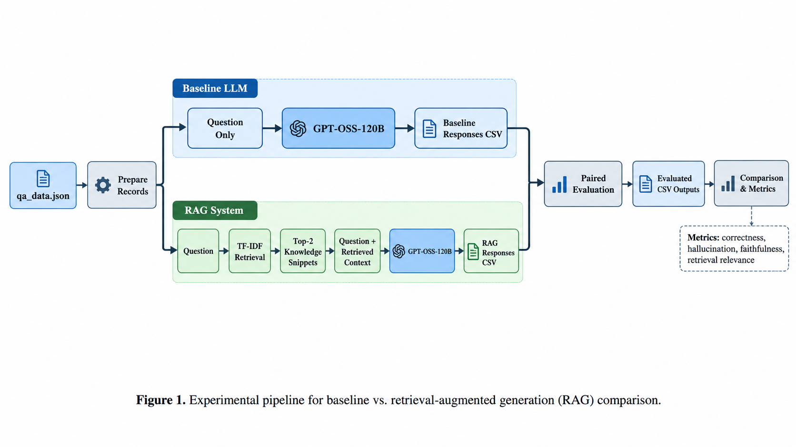

VI. RESULTS
The following figures summarize the current 100-question evaluated CSV files. The figures are descriptive and reflect the LLM judge's current annotations.
Metric | Baseline | RAG
Fully correct | 51/100 (51%) | 93/100 (93%)
Partially correct | 5/100 (5%) | 0/100 (0%)
Incorrect | 44/100 (44%) | 5/100 (5%)
Unanswerable / insufficient evidence | 0/100 (0%) | 2/100 (2%)
Hallucination = Yes | 44/100 (44%) | 3/100 (3%)
Hallucination = No | 56/100 (56%) | 97/100 (97%)
Faithfulness = Supported | 48/100 (48%) | 93/100 (93%)
Faithfulness = Partially supported | 7/100 (7%) | 2/100 (2%)
Faithfulness = Unsupported | 40/100 (40%) | 5/100 (5%)
Faithfulness = Not applicable | 5/100 (5%) | 0/100 (0%)

A. Hallucination-Label Comparison
The baseline has 44 hallucination-positive labels among 100 responses (44%), while RAG has 3 among 100 (3%). The absolute difference is 41 percentage points. The relative reduction from the baseline rate is (44 − 3) / 44 × 100 = 93.2%. This is the most prominent descriptive difference in the current evaluation. It should be phrased as a reduction in model-judge hallucination labels for this sample, rather than a claim that the RAG method will reduce hallucination by the same amount on other datasets or models.

B. Answer Correctness
The judge labelled 51 baseline answers fully correct, compared with 93 RAG answers. The baseline also received five Partially correct labels and 44 Incorrect labels. RAG received five Incorrect labels and two Unanswerable/insufficient evidence labels. The RAG result is consistent with better answer support in the current test, but abstentions should be assessed separately because avoiding an unsupported claim and providing a correct answer are different outcomes.

C. Faithfulness and Retrieval Relevance
Forty-eight baseline answers were labelled Supported and 40 Unsupported. For RAG, 93 were labelled Supported and five Unsupported. The retrieval evaluation labelled 95 contexts Relevant and sufficient, four Relevant but incomplete, and one Irrelevant. These results suggest the retriever frequently surfaced useful evidence. However, relevance is not a guarantee of entailment: a passage can be topically relevant without supporting every claim in the final answer.
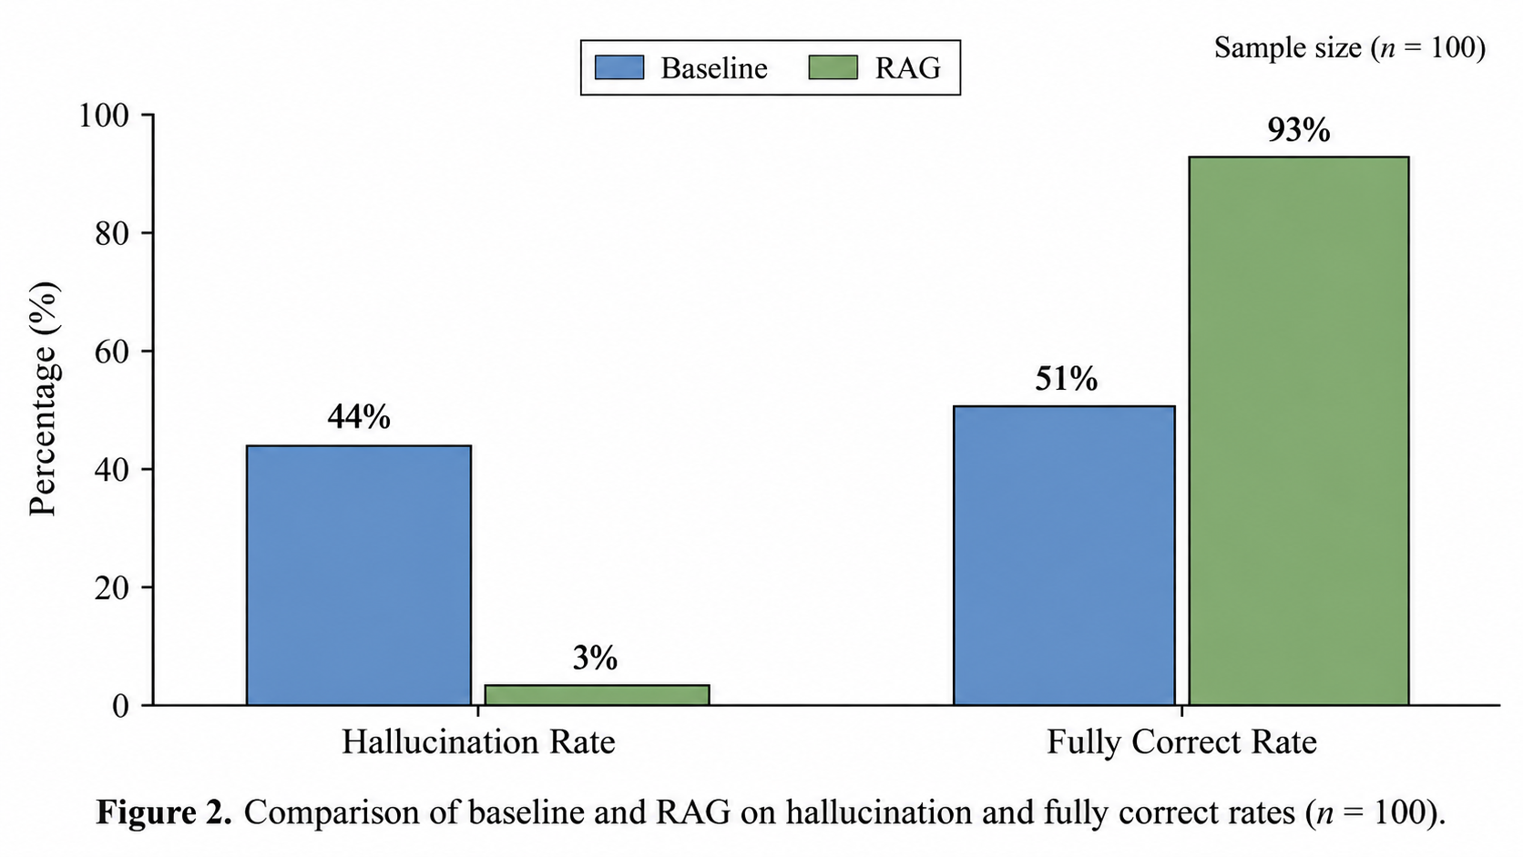
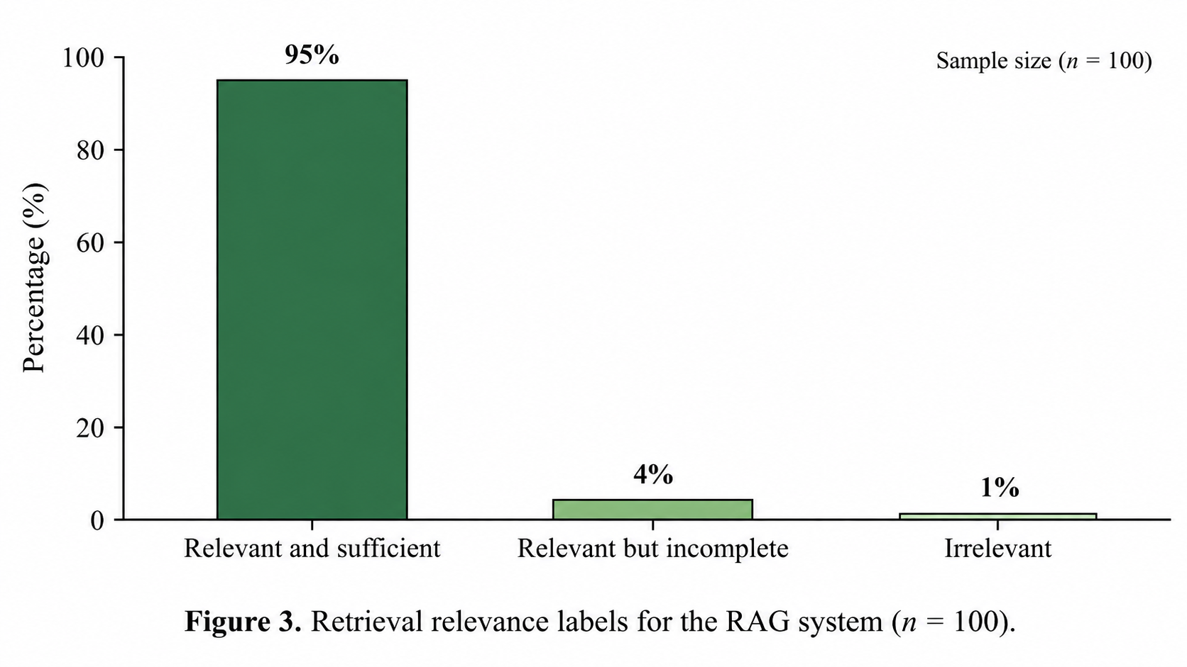

VII. DISCUSSION
The results favour the RAG configuration on all main descriptive comparisons included in the current evaluation: a higher fully correct count, a lower hallucination-positive count, and a higher supported-faithfulness count. One plausible explanation is that the RAG model can refer to explicit snippets at inference time, which can reduce reliance on unsupported parametric recall. This interpretation is consistent with the motivation for RAG described in the literature [2].
The effect should not be attributed to retrieval alone. The RAG condition changes both the available evidence and the prompting strategy. Its system instruction explicitly encourages use of the retrieved context and abstention when the evidence is insufficient. The experiment therefore estimates the performance of the overall RAG approach as implemented.
The retrieval corpus was constructed from the knowledge fields of the selected records. This is convenient for a course project and permits controlled retrieval, but it may make evidence easier to find than in an open-domain setting. A more demanding follow-up would use a separate, fixed corpus and would assess whether the retriever returns evidence from that corpus without directly relying on the target record's own knowledge field.
The LLM judge is another important limitation. The judge can misinterpret reference answers, miss unsupported details, or apply its rubric inconsistently. A stronger evaluation would include a written annotation rubric, manual review by at least one additional reviewer, and reporting of agreement on a shared subset. Human verification is especially important for borderline cases and for responses that are labelled correct while also containing a hallucination.

VIII. THREATS TO VALIDITY AND LIMITATIONS
- Sample validity: the 100 records were selected deterministically from the first records rather than randomly, so they may not represent the full dataset.
- Construct validity: hallucination, correctness, and faithfulness depend on operational definitions and the quality of the judge's labels.
- Internal validity: the RAG prompt differs from the baseline prompt; retrieved evidence and instruction changes are confounded.
- Retrieval validity: TF-IDF is a lexical baseline and may not capture semantic similarity or retrieve the most useful evidence.
- Corpus validity: the retrieval corpus was built from knowledge snippets in the selected records, not an independent real-world corpus.
- Reliability: a single model configuration and one run do not show whether results persist across model versions, prompt variations, or samples.
- Statistical uncertainty: descriptive percentages are reported; statistical significance should not be claimed without a paired analysis based on verified labels.
- Evaluation leakage risk: the evaluator should use the reference answer and designated evidence for judging, but the response-generation stage must preserve the intended baseline/RAG information difference.

IX. REPRODUCIBILITY AND ARTIFACTS
To support reproducibility, the source code, README, dependency list, experiment scripts, and configuration settings are available in the project repository. API credentials are excluded from the published artifacts. The experiment uses the HaluEval question-answering dataset, with the dataset source and subset selection procedure documented below.
Source code repository:
https://github.com/saklinetanvirr/Hallucination-Detection-and-Mitigation-of-LLMs
Dataset provenance:
The experiment used the question-answering dataset qa_data.json from the official HaluEval repository (https://github.com/RUCAIBox/HaluEval). A subset consisting of the first 100 usable records was selected from the dataset for the comparative evaluation. The selection followed the order of records in the local dataset file rather than random sampling. The dataset was used to provide questions, reference answers, and knowledge passages for the baseline and retrieval-augmented generation (RAG) experiments. The original dataset source is cited to acknowledge its provenance. For reproducibility, the dataset file, selection procedure, and experimental configuration should be documented alongside the source code. The exact dataset revision should be recorded if available.
X. CONCLUSION AND FUTURE WORK
This paper compared a question-only baseline with a lightweight TF-IDF-based RAG system on 100 paired questions using openai/gpt-oss-120b. In the current evaluated outputs, 51 baseline responses and 93 RAG responses were labelled fully correct. Hallucination-positive labels occurred in 44 baseline responses and three RAG responses. The observed rates were 44% and 3%, respectively, corresponding to a 41-percentage-point difference and a 93.2% relative reduction in the baseline-labelled rate. These results suggest that the tested RAG implementation improved answer grounding on this sample.
The conclusion remains specific to the selected data, model, retrieval method, prompts, and LLM-judge evaluation. The study does not establish that RAG always prevents hallucinations or that retrieval alone caused the entire observed difference. Future work should use a larger and preferably randomized sample, an independent retrieval corpus, controlled prompts, manual verification of labels, multiple models, alternative retrieval methods, and paired statistical analysis. It would also be useful to evaluate evidence citation quality and whether each factual claim is entailed by the retrieved passages.

REFERENCES
[1] J. Li, X. Cheng, W. X. Zhao, J.-Y. Nie, and J.-R. Wen, “HaluEval: A large-scale hallucination evaluation benchmark for large language models,” in Proc. 2023 Conf. Empirical Methods in Natural Language Processing (EMNLP), Singapore, 2023, pp. 6449–6464, doi: 10.18653/v1/2023.emnlp-main.397.
[2] P. Lewis et al., “Retrieval-augmented generation for knowledge-intensive NLP tasks,” in Advances in Neural Information Processing Systems, vol. 33, 2020. [Online]. Available: https://arxiv.org/abs/2005.11401.
[3] RUCAIBox, “HaluEval: A large-scale hallucination evaluation benchmark for large language models,” GitHub repository. [Online]. Available: https://github.com/RUCAIBox/HaluEval. Accessed: Oct. 22, 2026.

